CS 5404 Assignment 6

Wei Luo

1. **Briefly summary of what you think the project was about.**

This project is about to combine two related images into one big image, and it can also combine several related images into one big image with a little improvement.

1. **Briefly outline of the algorithmic approach.**

With two related images, I will use corner detector in source and destination images. I will use NCC as the metric to compare patches and match them together. Then, I will use RANSAC algorithm to find the optimal inlier set of correspondence points by matching patches. And use the inlier set of correspondence points to compute the Homography matrix. Based on the homography matrix and backward warping method. I create a mosaic image to combine two images.

1. Pictures of intermediate and finally results that convince me that your code does what you think it does.

There are three experiment here.

The first one is to use the images provided by the instructor.

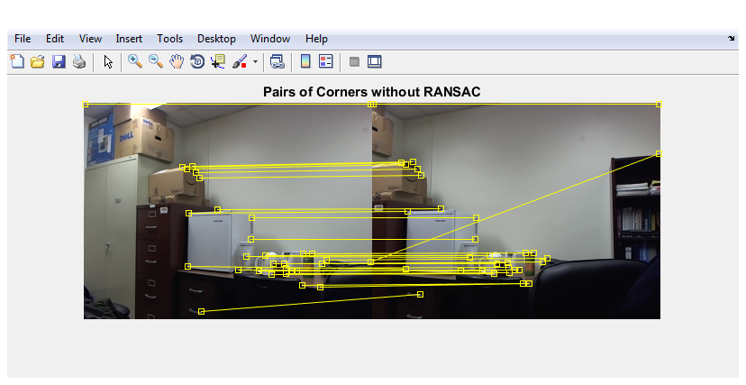

What I show above are the matched corners without RANSAC. In my RANSAC algorithm, I will find the inlier set of these corners and remove the outlier set.

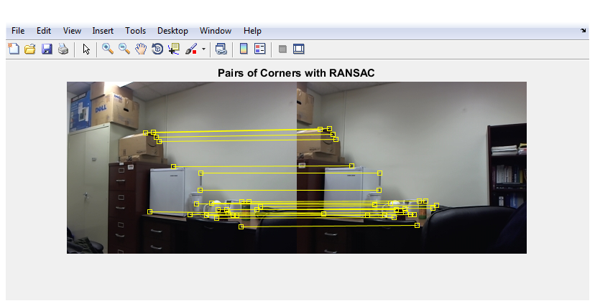

After RANSAC algorithm, I find the inlier set of corners, and I use them to compute the homography matrix. With this matrix, I do a backward warping on the source image to the destination image.

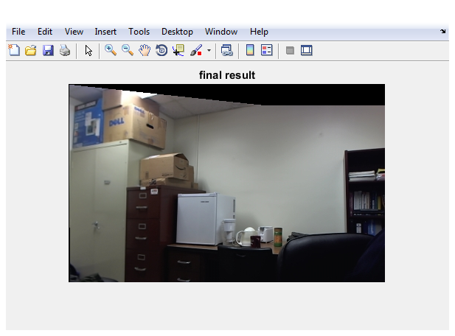

In the next two experiments, I would use some images I took from my camera.

Here is two similar images, so that they still have lots of matched corners after RANSAC.

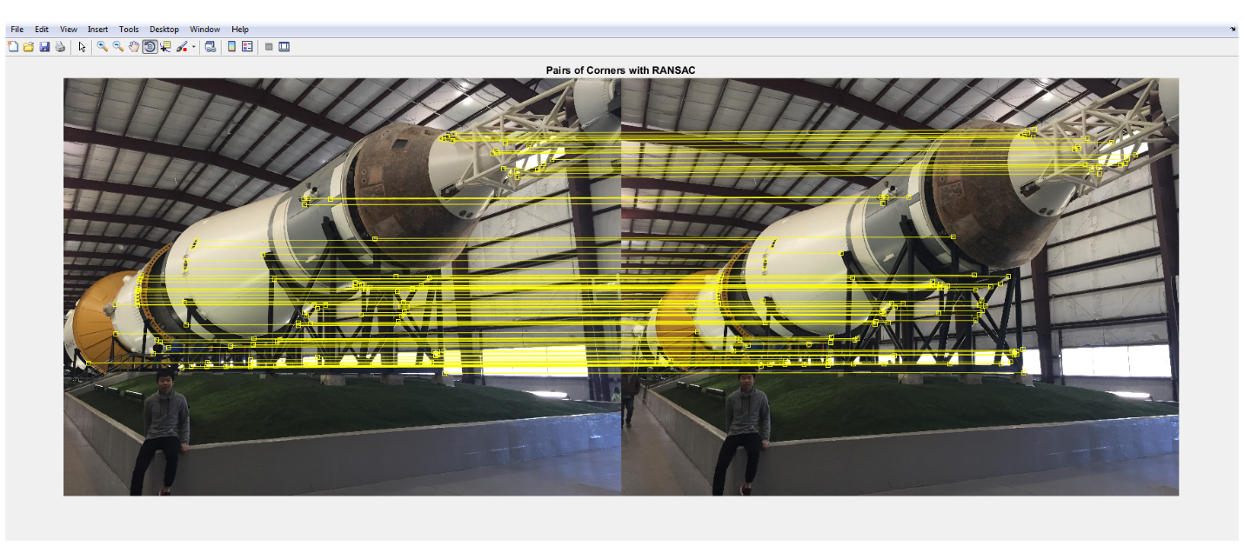

With these matched points, I can get an accuracy homography matrix, so that the final result is good.

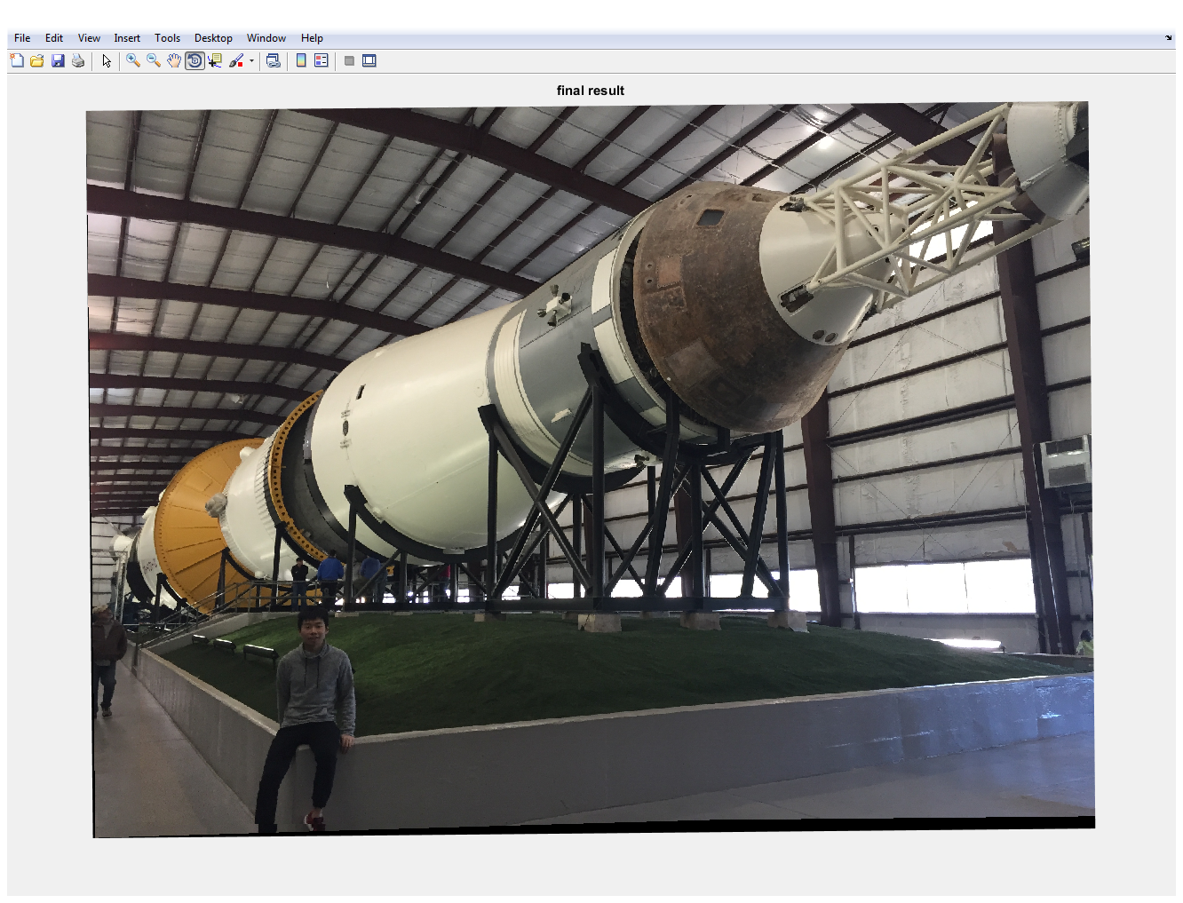

In the final experiment, I use two images with more difference. Of course, they also have some common places.

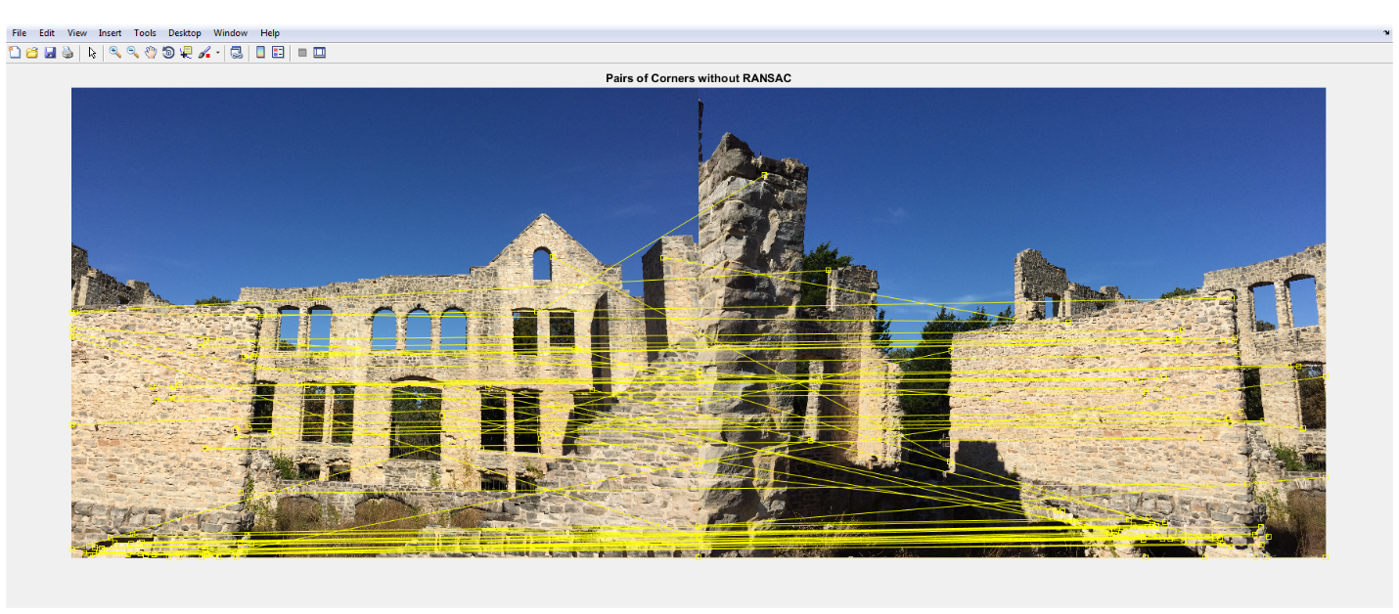

Without RANSAC algorithm, they also have many matched corners, after the RANSAC algorithm, they only have 20 inlier set points.

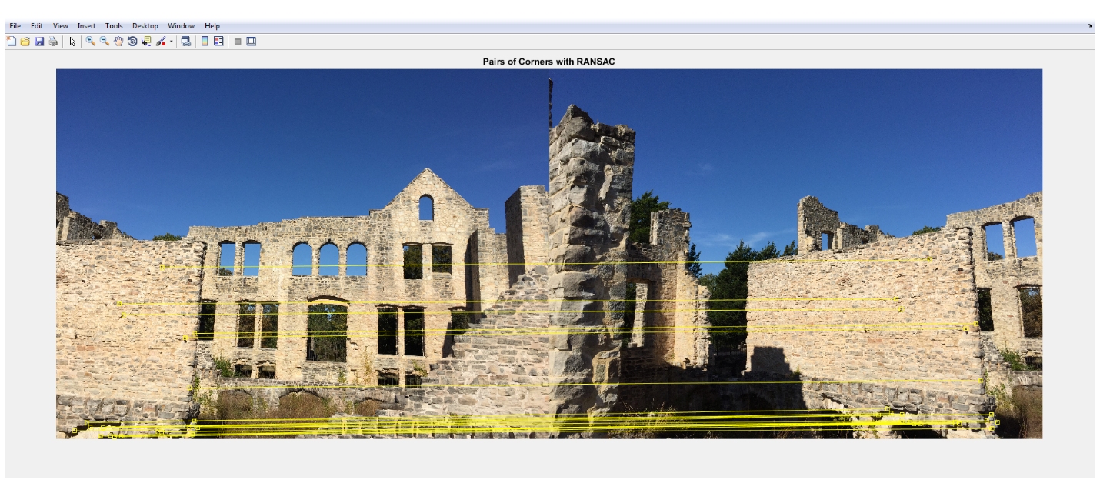

And the final result is also good.

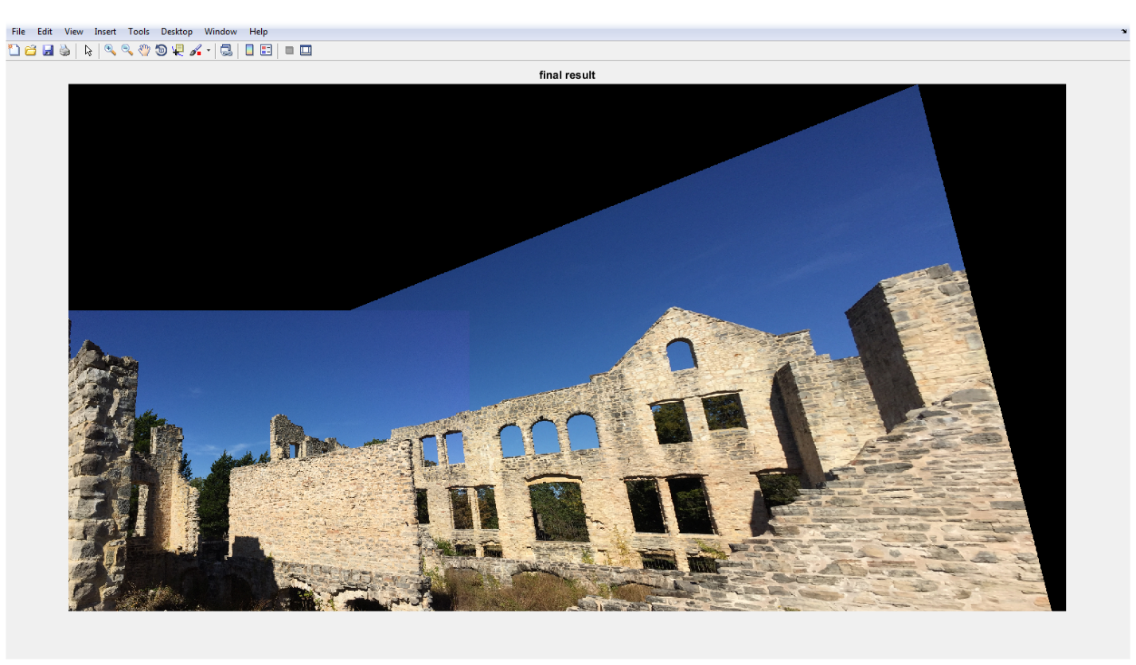

1. Any design decision you had to make.

In SANSAC algorithm, I decided that I should use at least 4 pairs of points to make sure the homography matrix. Besides, I also decide how to make sure the size of the final image. I use forward warping to the four corners of the source image to ensure the size of the final image, and I do a backward warping to transfer the source image into the destination image.

1. Experimental observations.

The result of the experiments are very good. In the future, we can add some operation on the final image, so that we can smooth the mosaic line.